NBA Player Performance & Salary Analytics Pipeline
CPSC 482 – Data-Intensive Systems | Final Report
Jacob Jarvis
May 2026

1. Project Overview and Goals
This project implements a complete end-to-end data analytics pipeline on Google Cloud Platform that processes over 70 years of NBA player statistics and 30 years of salary data. The pipeline ingests raw CSV datasets, stores them in Cloud Storage, transforms them using PySpark on Dataproc, warehouses the cleaned data in BigQuery, trains machine learning models to predict player salaries, and presents the results through an interactive Looker Studio dashboard.
The primary goals were to demonstrate proficiency with GCP data services, to generate meaningful analytics from a large real-world dataset, and to build a salary prediction model that identifies overpaid and undervalued NBA players based on their on-court performance statistics.

2. Dataset Description
The project uses four interrelated CSV datasets sourced from Kaggle, spanning player box scores, season averages, individual salaries, and team payroll.
Dataset | Raw Rows | Size | Coverage | Clean Rows
Player Box Scores | 1,309,778 | 158 MB | 1950–2022 | 1,183,956
Player Season Stats | 28,237 | 4.5 MB | 1950–2022 | 25,732
Player Salaries | 15,857 | 740 KB | 1990–2023 | 15,203
Team Payroll | 966 | 43 KB | 1990–2023 | 966

The box score dataset is the largest at 158 MB and 1.3 million individual game records. It contains per-game statistics including points, rebounds, assists, shooting percentages, and plus/minus for every player who appeared in an NBA game from 1946 through 2022. The salary data enables a unique analytical angle: predicting what a player should be paid based on their statistics and identifying discrepancies.
Data quality considerations include missing values for statistics not tracked in earlier eras (three-point shooting before 1979, steals and blocks before 1973), currency formatting in salary fields, and duplicate entries for players who were traded mid-season.

3. Pipeline Workflow and Services Used
The pipeline follows a six-stage architecture using core GCP services:
- Cloud Storage (GCS): Raw CSV files are uploaded to a GCS bucket (final-project-493902-nba-analytics) organized into raw/ and processed/ prefixes. GCS serves as the landing zone for ingestion and the intermediate storage layer between processing and warehousing.
- Dataproc (PySpark): A single-node Dataproc cluster running PySpark handles the data transformation: reading CSVs from GCS, cleaning and standardizing schemas, computing derived features, and writing the output as Parquet files back to GCS.
- BigQuery: Processed Parquet files are loaded into BigQuery as native tables. Six analytics views are created on top of these tables to support dashboard queries and ML training.
- BigQuery ML: Two regression models (Linear Regression and XGBoost) are trained directly in BigQuery SQL to predict player salaries from performance statistics.
- Looker Studio: A five-page interactive dashboard connects to BigQuery views and tables, providing filterable visualizations of player performance, salary analysis, and model predictions.
Figure 1: GCS Bucket – Raw Data Files
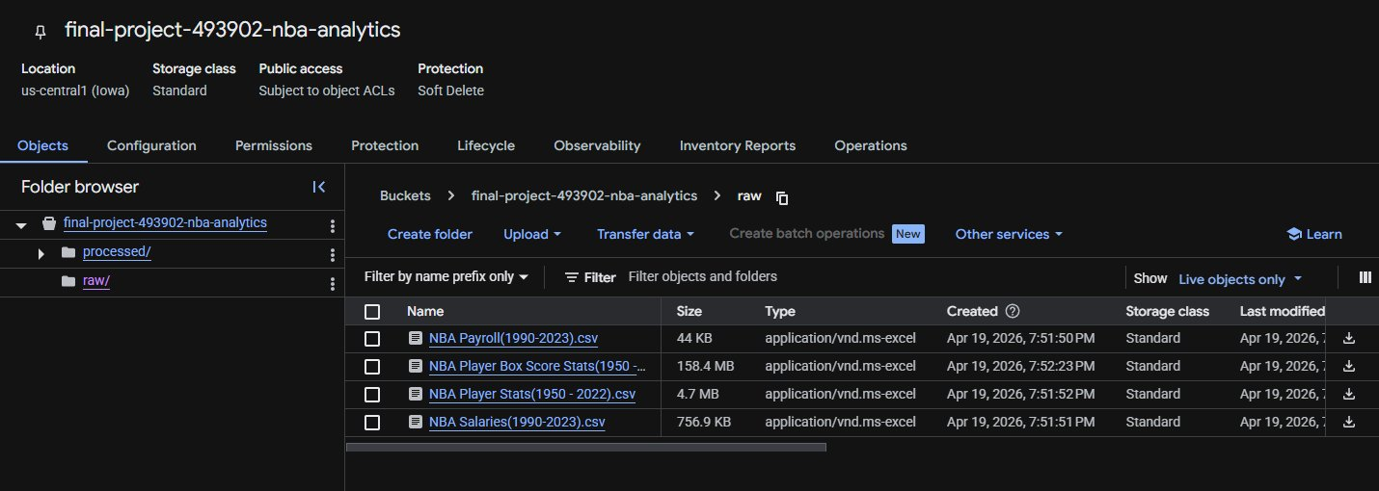

4. Data Processing Steps
Data processing was performed in two stages: first locally using pandas for development and testing, then on Dataproc using PySpark for the GCP pipeline demonstration.

4.1 Cleaning and Standardization
- Column renaming: All columns were renamed to consistent snake_case (e.g., PLAYER_NAME to player_name, FG_PCT to fg_pct).
- Type casting: Numeric fields were cast to appropriate types (INTEGER for counts, FLOAT for percentages). Date strings were parsed from formats like "NOV 19, 1946" to proper date types.
- Currency cleaning: Salary and payroll fields containing dollar signs and commas (e.g., "$4,070,917") were stripped and cast to integers.
- Filtering: Box score rows with zero or null minutes were removed. Season stats rows with team = "TOT" (aggregate rows for multi-team players) were dropped.
- Deduplication: Records were deduplicated on composite keys (player_name + game_id for box scores, player_name + season + team for season stats).

4.2 Feature Engineering
- Per-36-minute stats: Points, rebounds, and assists were normalized to a per-36-minute basis to enable fair comparison across players with different minutes.
- True Shooting Percentage: Computed as PTS / (2 * (FGA + 0.44 * FTA)), providing a single efficiency metric that accounts for free throws and three-pointers.
- Home/away flag: Derived from the matchup string ("vs." indicates home, "@" indicates away).

4.3 Dataproc Execution
The PySpark job was submitted to a single-node Dataproc cluster (n1-standard-4, 100GB disk) and completed successfully, processing all four datasets and writing Parquet output to GCS.
Figure 2: Dataproc PySpark Job Output
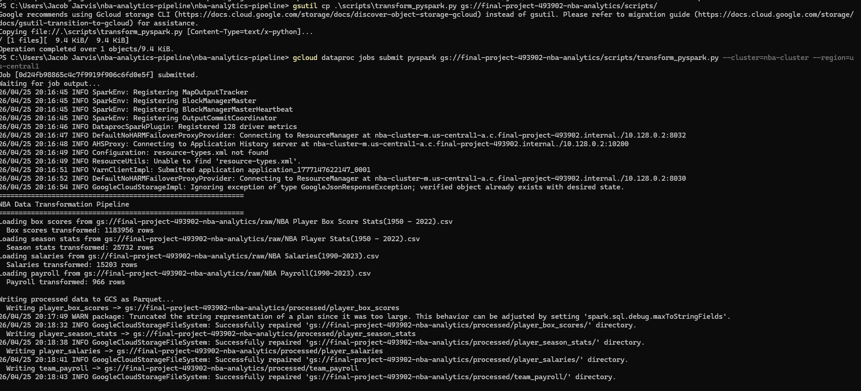
Figure 3: Dataproc Job Completion (status: DONE)
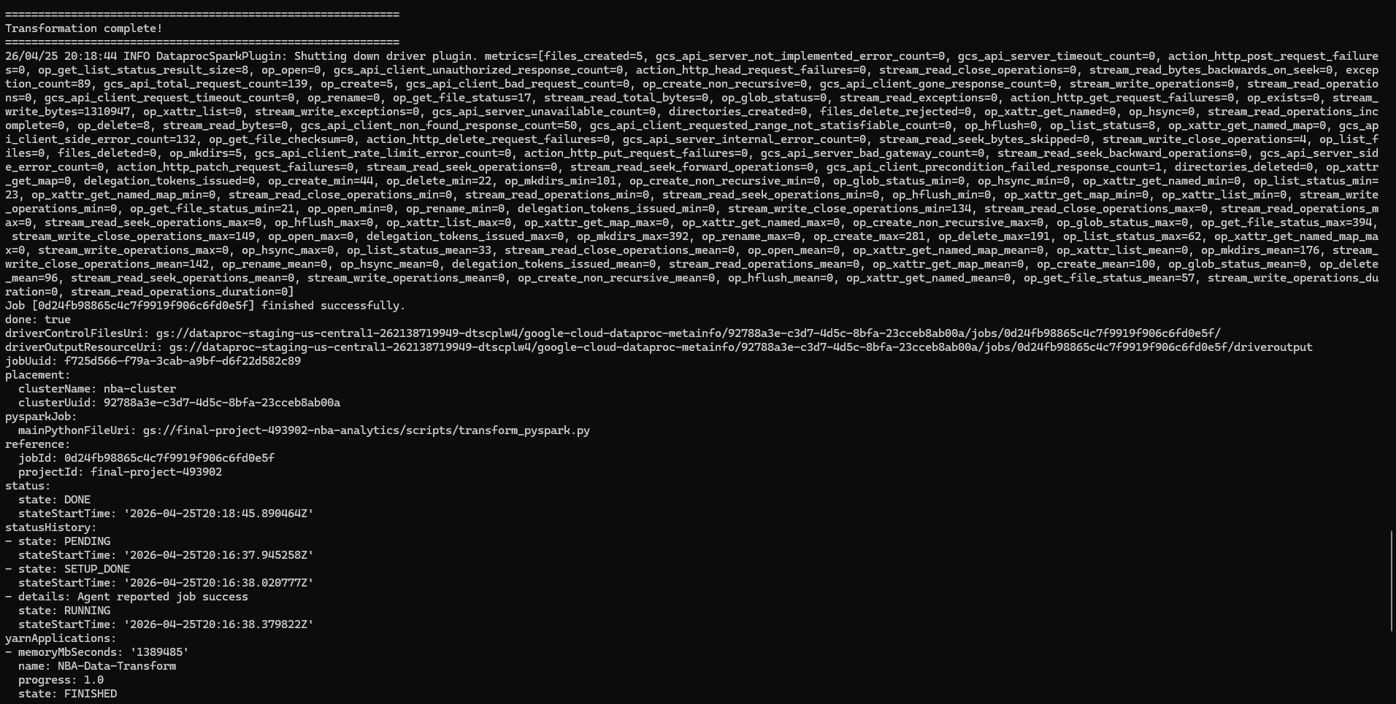

5. Results Obtained

5.1 BigQuery Tables
Four processed tables were loaded into BigQuery with the following verified row counts:
Figure 4: BigQuery Row Count Verification
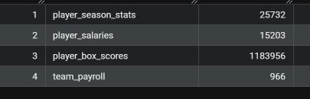
Six analytics views were created to support the dashboard and ML workflows: v_player_season_averages, v_player_careers, v_league_trends, v_player_stats_with_salary, v_team_spending, and v_ml_salary_training.
Figure 5: BigQuery player_box_scores Schema (30 fields)
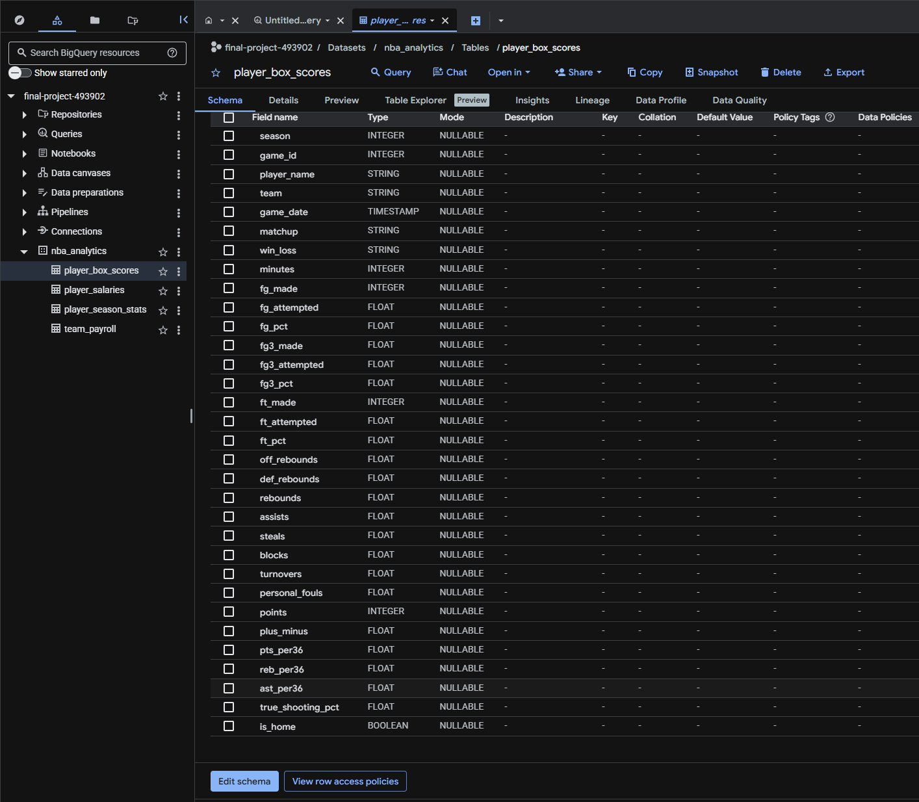

5.2 BigQuery ML Models
Two regression models were trained to predict a player's inflation-adjusted salary from their season statistics. The features used were: age, games played, minutes per game, points, rebounds, assists, steals, blocks, field goal percentage, three-point percentage, and effective field goal percentage.
Model | R² Score | MAE | Explained Var.
Linear Regression | 0.381 | $4.07M | 0.383
XGBoost (Boosted Tree) | 0.484 | $3.53M | 0.487

The XGBoost model outperformed linear regression across all metrics, achieving an R² of 0.484 and reducing mean absolute error by approximately $540K. The moderate R² reflects the reality that NBA salaries are influenced by many factors beyond on-court statistics, including draft position, marketability, team cap situations, and contract timing.
Figure 6: Model Evaluation Results

5.3 Salary Predictions
The XGBoost model was used to generate predictions for all players in the training dataset. Players were then ranked by overpay amount (actual salary minus predicted salary) to identify the most overpaid players. The top overpaid players include Mike Conley (2020, $31.3M overpay), Gordon Hayward (2019, $28.7M overpay), and Paul George (2018, $25.4M overpay) — cases where injuries or role changes reduced production while salaries remained locked in from earlier contract negotiations.
Figure 7: Most Overpaid Players (BigQuery Query Results)
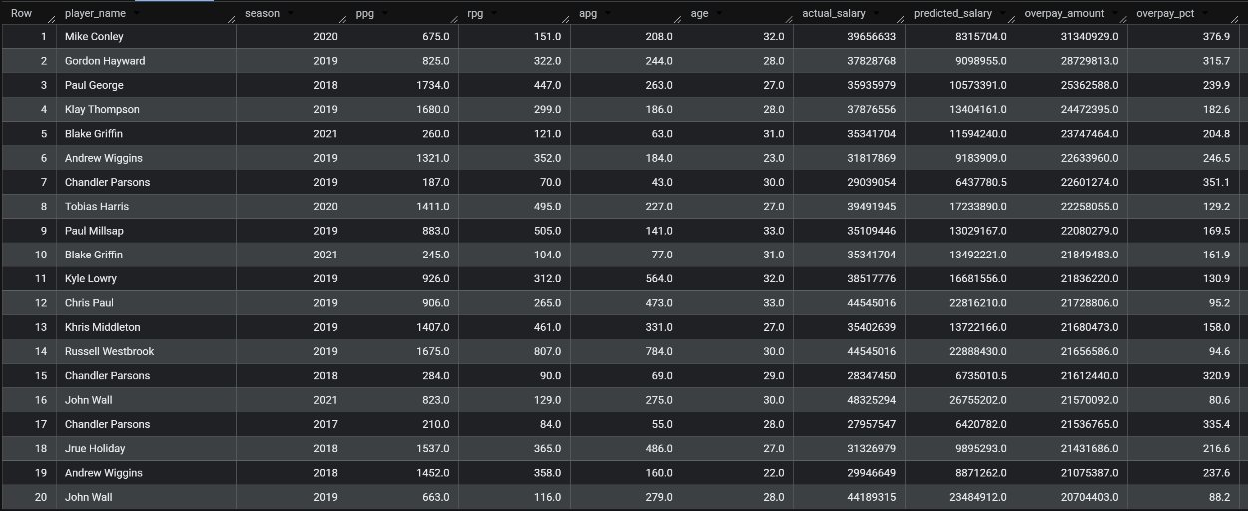

6. Visualizations / Dashboard
A five-page interactive dashboard was built in Looker Studio, connected directly to BigQuery views. Each page serves a distinct analytical purpose:

6.1 League Trends
Line charts showing league-wide scoring, rebounding, and assist averages from 1950 through 2022, alongside a dedicated three-point attempt trend chart that clearly visualizes the three-point revolution accelerating from the mid-2010s onward.
Figure 8: League Trends Dashboard Page
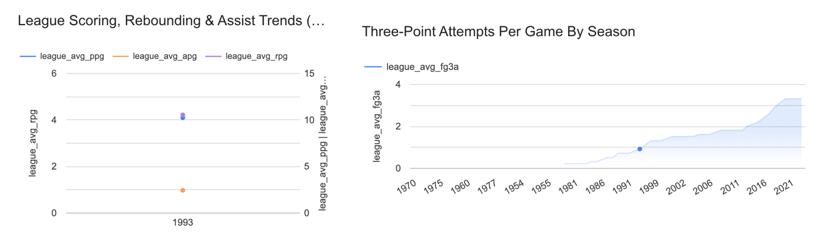

6.2 Player Performance Explorer
A filterable table and bar chart allowing users to select any player and view their season-by-season statistics including PPG, RPG, APG, true shooting percentage, and minutes per game.
Figure 9: Player Performance Explorer
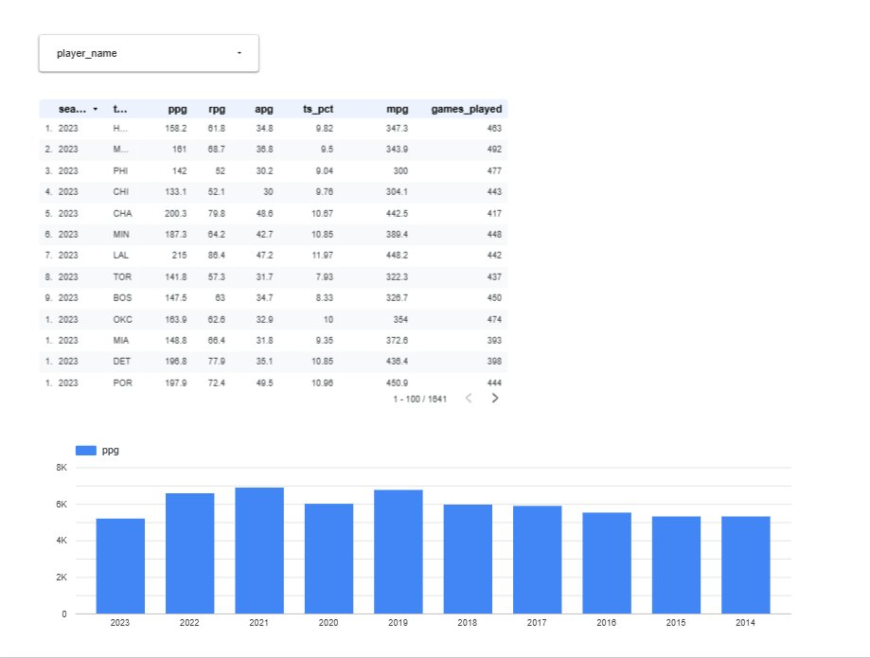

6.3 Career Leaders
Horizontal bar chart of all-time career points leaders and a scatter plot of career PPG versus true shooting percentage, revealing the relationship between volume scoring and efficiency.
Figure 10: Career Leaders Dashboard Page
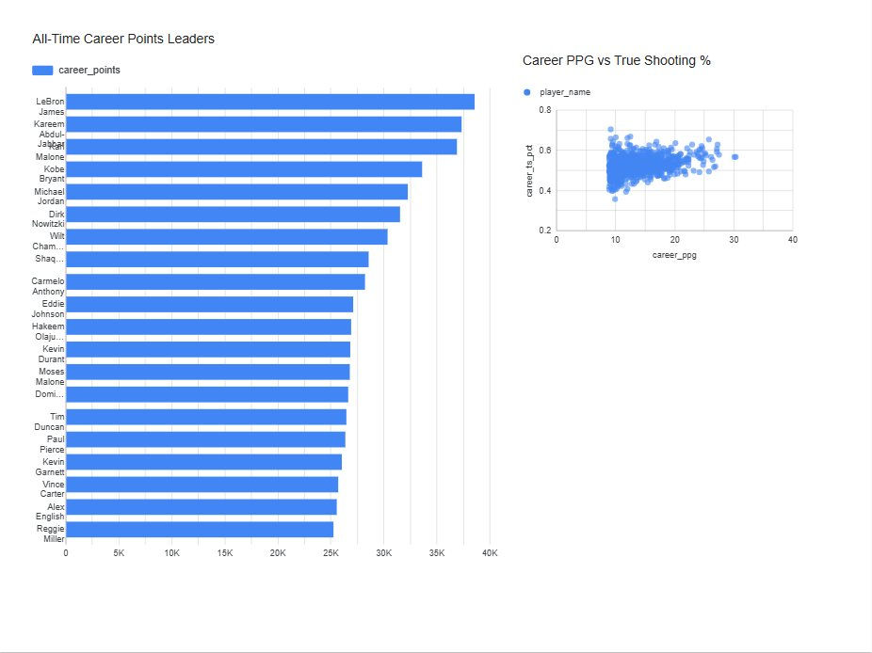

6.4 Salary Analysis
A scatter plot of PPG versus salary showing the general positive relationship, alongside a table of the best-value players ranked by PPG per million dollars of salary.
Figure 11: Salary Analysis Dashboard Page
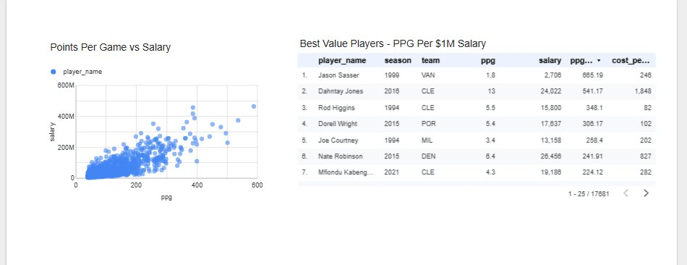

6.5 ML Predictions
Predicted versus actual salary scatter plot from the XGBoost model, plus a table of the most overpaid players with actual salary, predicted salary, and overpay percentage.
Figure 12: ML Predictions Dashboard Page
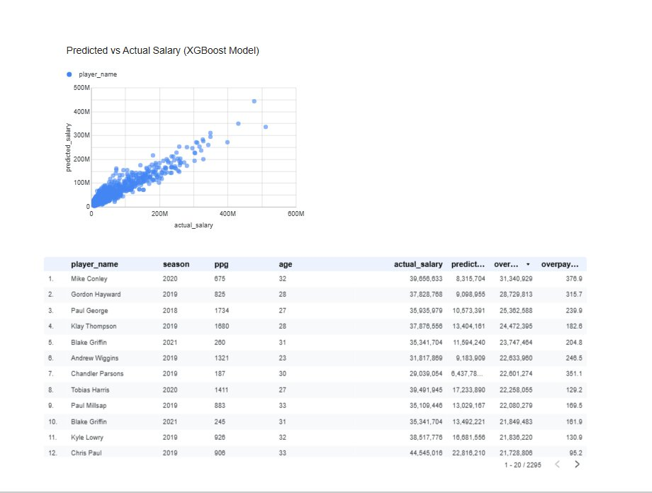

7. Challenges Encountered and Resolutions
- GCP project ID vs. display name: The project's display name ("final-project") differed from its ID ("final-project-493902"), causing repeated errors with gcloud, gsutil, and bq commands. Resolved by running gcloud projects list to discover the correct ID.
- Billing configuration: GCS bucket creation returned a 403 billing error because no billing account was linked. Resolved through the GCP console by linking a billing account to the project.
- PowerShell vs. Bash: The pipeline automation script was written for Bash, but development occurred on Windows PowerShell. Environment variable syntax (export vs $env:), argument separators (--), and path conventions all required adaptation. Resolved by running commands individually with PowerShell-compatible syntax.
- Dataproc argument passing: PowerShell stripped the -- separator needed to pass arguments to PySpark scripts via gcloud dataproc jobs submit. Multiple workarounds failed. Resolved by hardcoding the bucket name in the PySpark script to eliminate the argument dependency entirely.
- File naming: CSV filenames contained spaces and parentheses (e.g., "NBA Player Box Score Stats(1950 - 2022).csv"), causing FileNotFoundError in Python scripts. Resolved by updating all file path references to match the exact filenames.
- Missing historical statistics: Several statistical categories (steals, blocks, turnovers, three-point stats) were not tracked by the NBA until the 1970s. These null values were retained rather than dropped, allowing basic scoring and rebounding analysis to span the full 1950–2022 range while advanced analysis is limited to modern eras.

8. Lessons Learned
- Test locally before deploying: Running the pandas transformation first caught schema and data quality issues without incurring Dataproc costs. The local Parquet output could also be uploaded directly to BigQuery as a fallback path.
- Schema standardization is foundational: Consistent column naming and type casting across sources was the most important preprocessing step. Without it, downstream joins and views would have failed silently or produced incorrect results.
- Cost management requires deliberate design: Using a single-node Dataproc cluster with auto-delete, BigQuery's free tier, and minimal GCS storage kept total project costs under $3. This required conscious choices at each stage.
- Iterative development prevents cascading errors: Building the pipeline stage by stage with verification queries at each step (e.g., row count checks after loading) caught issues early before they propagated downstream.
- ML models reveal domain complexity: The moderate R² (0.48) of the salary prediction model is itself an insight: NBA salaries are only partially explained by on-court statistics. Contract timing, market dynamics, draft position, and team salary cap constraints all play significant roles that pure performance metrics cannot capture.

9. Potential Next Steps
- Incorporate advanced metrics: Adding PER, BPM, VORP, and Win Shares from Basketball Reference would strengthen the ML model's feature set and likely improve salary prediction accuracy.
- Time-series forecasting: Build models that predict next-season performance based on historical trajectory, age curves, and injury history.
- Streaming ingestion: Replace batch CSV ingestion with a Cloud Functions-based pipeline that pulls live game data from the NBA API on a nightly schedule, enabling near-real-time dashboard updates.
- Team-level analysis: Expand the payroll analysis to include win totals and playoff results, enabling a cost-per-win analysis at the team level.
- Pipeline orchestration: Add Cloud Composer (Airflow) to automate the full pipeline from ingestion through model retraining and dashboard refresh on a scheduled basis.

